SENNHEISER TO DELIVER PREMIUM UC HEADSETS to TIME2MARKET’s NATIONWIDE community of business customers
T2M’s extensive customer base includes hosted VoIP clients and multi-location end-users with distributed campuses

Old Lyme, CT, October 15, 2018 – Sennheiser, a leading provider of premium audio solutions, announces it has been selected by major leading UC systems integrator and hosted VoIP provider Time2Market to provide Sennheiser high-performance headsets to T2M’s customer base. Time2Market, based in Denver, CO, is a major Microsoft Gold Communications partner focused on the delivery of unified communications solutions serving SMB, mid-market and enterprise organizations with multiple, distributed locations, typically between 500 and 5,000 seats. Time2Market will offer the full line of Sennheiser premium business headsets for UCaaS and VoIP deployments as part of this provider’s Cloud Complete© offering. All of Sennheiser’s headsets are certified for Skype for Business.

Time2Market has worked with Sennheiser for eight years. The provider recently embarked on an official round of testing of the audio leader’s comprehensive line of business headsets in order to add Sennheiser to its list of approved vendors. T2M delivers top-tier solutions to end-companies in a variety of verticals from retail to petro chemicals, with a commonality being businesses that maintain multiple regional branch offices throughout the United States.

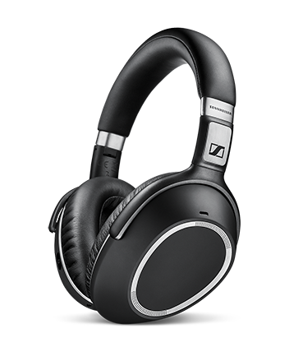 | Sennheiser’s MB 660 mobile business headset for unified communications environments addresses the distractions of the open office workplace with AANC, or active adaptive noise cancellation, which workers can modulate over the course of the day.
Proliferating Superior Audio Quality From a Trusted Partner
“The agreement with Time2Market is terrific news, for us and for businesses who are looking to enhance their unified communications experiences through the application of premium audio. We’re proud to be selected by such a prominent and successful provider,” said Doug Bowersox, western regional sales director, Sennheiser Enterprise Solutions/Americas. “T2M has shown national leadership in the deployment and support of Skype for Business Microsoft environments. We’re excited to introduce our superior sound quality to Time2Market’s wide breadth of customers and prospects, bringing Sennheiser quality to a range of top-tier enterprise workplaces.”

Sennheiser’s linecard includes the MB 660 headset, with adaptive active noise cancellation; plus the MB PRO series and PRESENCE mobile headsets; and the D 10, DW, SD wireless, Century, Circle, and Culture series. All Sennheiser’s headset solutions are compatible with the industry’s most widely deployed UC environments, including Cisco and Avaya platforms.

“We’re thrilled to include an audio pioneer like Sennheiser on our vendor roster, adding an outstanding brand of endpoint devices to our solution portfolio. Sennheiser provides superior sound backed by a history of ongoing innovation and accomplishments in the field of audio engineering,” said Todd Whisler, marketing director, Time2Market. “They’ve created an impressive line-up of devices that serve not just as components of a communications network, but are purpose-built to address the unique requirements of modern, hosted UC environments.”

about Sennheiser
Sennheiser is shaping the future of audio – a vision built on more than 70 years of innovation culture, which is deeply rooted within the family-owned company. Founded in 1945, Sennheiser is one of the world’s leading manufacturers of headphones, microphones and wireless transmission systems. With 20 sales subsidiaries and long-established trading partners, the company is active in more than 50 countries and operates its own production facilities in Germany, Ireland and the USA. Sennheiser has around 2,800 employees around the world that share a passion for audio excellence. Since 2013, Sennheiser has been managed by Daniel Sennheiser and Dr. Andreas Sennheiser, the third generation of the family to run the company. As part of the Sennheiser Group, the joint venture Sennheiser Communications A/S is specialized in wireless and wired headsets and speakerphones for contact centers, offices and Unified Communications environments as well as headsets for gaming and mobile devices. In 2016, the Sennheiser Group had sales totaling €658.4 million. www.sennheiser.com

about TIME2MARKET
Time2Market LLC is a leading unified communications integrator and cloud service VoIP provider delivering a “white glove” quality of experience. The portfolio includes Network Consulting, SD-WAN solutions and a Managed Services practice. Time2Market is Your IP Voice Expert. www.t2mdev.com

Global Contact

Bianca Nesgaard
bnes@senncom.com
T + 45 4470 0162
M + 45 3124 2622

